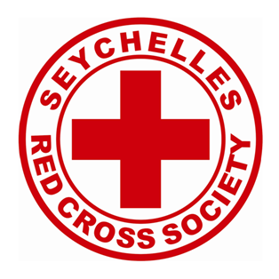

ANNUAL REPORT OF THE RED CROSS SOCIETY OF SEYCHELLES 2020

TABLE OF CONTENT
Contents
ANNUAL REPORT OF THE RED CROSS SOCIETY OF SEYCHELLES 2020 1
TABLE OF CONTENT 2
INTRODUCTION 3
BACK GROUND 4
RCSS STRATEGIC PLAN 2017-2021 5
THE RCSS CONTINGENCY PLAN 6
RISK COMMUNICATION AND COMMUNITY ENGAGEMENT (RCCE) 7
RCCE SURVEY 7
Conclusion 8
TRAININGS 9
COMMUNICATION AND ADVOCACY 11
COMMUNICATION IN THE RED CROSS SOCIETY OF SEYCHELLES DURING COVID 19 11
COMMUNICATING AND RESPONDING TO OTHER DISASTERS DURING COVID 19 14
Annex 1: COVID 19 Communication Plan 15
Target Groups 15
WORKING WITH THE MINISTRY OF HEALTH 17
PSYCHOSOCOLOGICAL FIRST AID 18
WORKING WITH THE MINISTRY OF EDUCATION (MoE) 19
RAISING THE STANDARDS OF THE RCSS HEADQUARTERS 23
UPGRADING OF RCSS IT SYSTEM 23
VOLUNTEER DATABASE 24
RCSS PARTICIPATION IN THE NATIONAL GENERAL ELECTIONS 24
RCSS FINANCIAL STATEMENT 2020 27

INTRODUCTION
The year 2020, marks a milestone in the history of the Red Cross Society of Seychelles, RCSS. This is where our capacity and resources were tested to deal with one of the worst health situations the world has ever faced and still facing.

COVID 19 has been at the forefront of our activities since the beginning of 2020, ranging from providing assistance to the Ministry of Health and the Ministry of Education to providing psychosocial support to people affected by the pandemic.

Seychelles reported its first two cases of COVID-19 on the 14th of March 2020.

In our capacity therefore as an Auxiliary partner of the government, the Red Cross Society of Seychelles has been a part of national efforts in fighting against COVID-19 since the first positive case was reported where we have been able to contribute our volunteer resources in support actions mainly alongside the Ministries of Health and Education, whilst allowing our volunteers to obtain practical skills as part of the activities which included: Contact Tracing, Psychosocial support and Logistics assistance (food and provisions) for the vulnerable (families and expatriates) during the lockdown period.

This well-coordinated collaboration, ensured that available resources, including equipment and facilities were effectively and efficiently distributed and utilized for the benefit of all.
Capacity building has also been one of the strong points during this year, where volunteers and staff have been trained in various areas related to COVID 19, such as psychosocial support, dissemination and education on COVID 19, and community-based surveillance, to name a few. During this year, the National Society has been proven to be the preferred humanitarian organisation in the country, mainly through its efficient delivery of services and assistance, reliability and credibility. The array of activities implemented with its network of volunteers and staff has enabled the NS to secure financial assistance of more than….SR from international donors. The Seychellois community also provided donations to all those affected, and those who lost their jobs due to COVID 19. Donations in the form of cash and\or kind coming from individuals, organisations, partners and so forth have enabled us to assist over…. households; a total of ….people.
Perhaps one of the most challenging feats was the lack of human resources to implement the activities. At the start of the pandemic the RCSS was operating with only three staff (3), each doing multiple tasks to ensure that all requests coming in was dealt with effectively and accordingly. Thus, the NS used the COVID situation to advocate for more financial, and logistics support to better play its role as auxiliary to the authorities.
We can therefore say that the year 2020 was both an eye-opener as well as a golden opportunity for the Red Cross Society of Seychelles

BACK GROUND

The Red Cross Society of Seychelles (RCSS) was founded in August 1989. With the enactment of the RCSS ACT of1991, the National Society was officially recognized as a voluntary relief society and auxiliary to the public authorities in the humanitarian field. In accordance with the Geneva Convention of which the government of Seychelles is party to, the RCSS is the only Red Cross Society authorized to carry out its activities in the Seychelles territory.

The RCSS is guided in what it does by its statutes and Rules and Regulations and being a component of the Red Cross Movement and a member of the International Federation of the Red Cross Red Crescent Movement, it is further guided by the Movement’s 7 Fundamental Principles.

The central organization of the RCSS comprises of a General Assembly (paid up members /volunteers) that meets every three years and votes in the governance component responsible for decision and policy making for the National Society. The governance component is comprised of a President, two Vice Presidents and four ordinary members.

The management component of the organization is responsible for the implementation of decisions and policies and is comprised of employed staff under the leadership of a Secretary General. The core administrative staff is responsible for the day to day running of the National Society and coordination of its activities and programmes, and is presently comprised of a Secretary General, a Programme Coordinator, a Health Coordinator, a Finance Coordinator, a Planning, Monitoring Evaluation Reporting Coordinator, a Logistics Officer and an Administrative Officer.

The RCSS is also comprised of over 50 active volunteers who is responsible for the implementation of the National Society’s activities. Volunteers are based on Mahe Praslin and La Digue

The beneficiaries of the RCSS are not limited to community groups namely the youth & elderly, and other individuals through workplace programmes. The RCSS operates from its headquarters on Mahe, however assistance and services are provided in any location that is required or as requested.

RCSS STRATEGIC PLAN 2017-2021

Strategic areas of the RCSS Strategic Plan 2017-2021 are:

SG 1.Reduce vulnerability, losses , damage and other detrimental consequences of disasters and crises
SG 2
Contributing towards promoting safe and healthy living and responding to health needs in emergencies
SG 3
Promote the practical application of the Fundamental Principles and a culture of non violence and peace
SG 4
Enhanced organisational development of the RCSS to effectively and efficiently plan, implement and sustain services and programmes
SG 5
Influence decision makers and partners to better consider the needs of the most vulnerable people

The Strategic Goals form the basic foundation for ‘Enabling Actions’ and with the coming of COVID 19, 2020 brought the need to review the Actions. This in order, not to change, but to be able to contextualise, each point so as to facilitate our work within the COVID 19 environment.

THE RCSS CONTINGENCY PLAN
Due to the changes caused by the COVID 19 pandemic, documents enabling strategic actions needed to be reviewed or devised as applicable. This, to ensure that the IFRC guidelines and the NS policies therein were in line with National Laws and regulations guiding health and safety actions and practices.
Focussing on the Enabling Actions within the Strategic Plan as a way-forward, the RCSS reviewed and activated its Contingency Plan in the second week of March 2020 after the initial COVID 19 case was recorded in Seychelles. The reviewing was done in a session with the National Committee Members, & RCSS staff.
The Contingency Plan is in line with the National Government COVID-19 Communication and Response Plan and Standard Operating Procedures (SOPs) and that of the RCSS Disaster Management Plan and Response.

The objective of the Contingency Plan was to strengthen the surveillance system and response capacity to the COVID -19 in Seychelles, and provide support to the Ministry of Health. The Contingency Plan also consists of a Communication and Media Plan.
The plan has been developed to enable the RCSS to be better prepared and ready to respond to COVID 19 and is in line with the National Government COVID 19 Communication and Respond Plan (CRP) and Standard Operating Procedures (SOPs), as well as that of the NS’s Disaster Management Response (DMR) Plan.

RISK COMMUNICATION AND COMMUNITY ENGAGEMENT (RCCE)
RCCE, had in fact become a ‘life saving’ topic and it was necessary to train ourselves and educate others, so as to enable better understanding and Best Practice.
For the RCSS, as for many of our partners RCCE was a new terminology. It took us a while to get used to the words ‘Risk Communications and Community Engagement’ and a little longer for us and most of our volunteers to contextualise RCCE within what we were doing as part of our Covid 19 work alongside partners.
However, once we acquired the understanding of the practicalities, it all became easy and even more importantly, it became clear that it was actually not a new theory but rather just a concept we had already been using and advocating in other areas such HIV/ AIDS and the use of condoms, prevention of the spread of other communicable diseases. The difference this time, was that the term had been contextualised within an emergency environment.

RCCE SURVEY
In order to evaluate the NS’ progress in RCCE in the community and also to assess public theory and practical knowledge and understanding of this very important aspect of ‘keeping safe’, the NS conducted an RCCE Survey during the third quarter of 2020.

This exercise involved some thirty (30) volunteers from all regions of Mahe, Praslin and La Digue who formed small groups and went into communities to meet people of all age groups to participate.

The survey was conducted on a Saturday morning and over 500 people were reached and shared their thoughts and views. The locations covered included: the main bus terminal in Victoria, one main shopping mall, housing estates and random people met on the streets or other sites around the areas covered.

The main tool utilised for the event was a Survey form, initiated and developed by the NS with open questions leading those interviewed to answer questions covering

- Their general understanding of the ‘health and hygiene’ practices to protect themselves against COVID 19
- How employing those practices were helping them to stay safe and healthy as well as to protect their family members and those around them
- Their views about the dissemination of information about RCCE from the MoH and other related parties
- Their views about the dissemination of information and IEC as well as hygiene materials (masks, sanitizers…etc} by the RCSS
- What they thought should be done further or more to protect communities against COVID 19

For this activity, the NS provided participating volunteers with a T-shirt with ‘Your face masks may protect them and their face masks may protect you’ written at the back, a food and internet allowance (volunteers were required to post and tag the ‘advisory’ on their social media pages and apps during the activity) and relevant stationeries to allow them to conduct the survey successfully.

The findings from the survey revealed that;

- 90% of people interviewed were satisfied with what the RCSS was doing to provide information and assistance to promote safety and help prevent the spread of COVID 19 in the community
- Over 75% of people interviewed felt that the MoH was trying its best to educate people about safety, prevention and hygiene regulations to stop the spread of the virus; but that the population was not cooperative in responding to the measures in place and a lot of people were still unheeding of advice.
- 99% of people interviewed felt that more could be done to spread more information and counselling about how NOT to spread the virus
- 100% of volunteers participating in the survey was satisfied with the organisation and implementation of the activity and felt that it had helped them to learn more about how things were in the community and how well people were adapting to the ‘new normal’ situation at the point of conduction of the survey.

Conclusion
The conclusion drawn following the survey was that; the RCSS, rightfully in its role as the most prominent humanitarian, auxiliary to the Government was on the right track in educating the people about this new virus.
It was also noted that the level of trust placed in the NS had increased and that people of all ages and statuses in the community were appreciative and supportive of the work we were doing alongside the mandated government entities to mitigate the impact of Covid 19 on our society and the wellbeing of the people, families and children in particular.
However, we also committed to do even more and go even further to be able to protect and sustain specific groups in communities as much as possible.

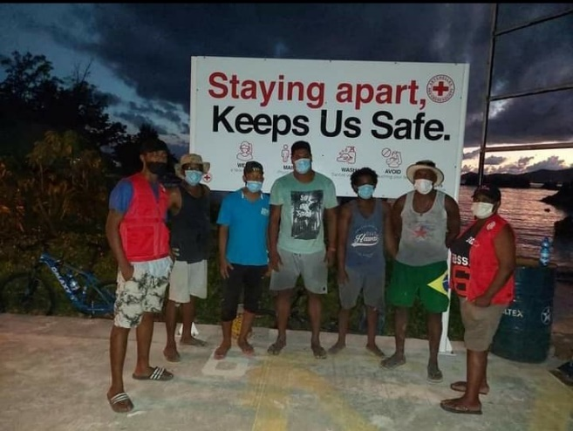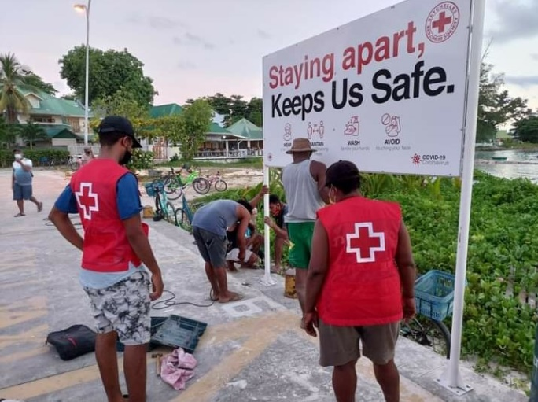

TRAININGS
The building of volunteer and staff capacity in advocacy and operational knowledge to cater for the ever-evolving changes and dynamic environment as well as to ensure continuity in RCSS programmes and services; has always been a priority for the NS.
Furthermore, with the arrival of COVID 19 in Seychelles, we had to take into serious consideration that, in order for our involvement in the mitigating efforts and actions against COVID 19 to be effective and meaningful, there was a need to facilitate and allow the empowerment of our volunteers in all relevant fields wherever opportunities presented whether from us or our partners.
In view of the fact that our involvement in national efforts was becoming more imperative, there was also a necessity to train newly recruited volunteers (a lot of new people joined the NS to be an active part of the COVID 19 efforts) in the Red Cross Principles and other basic rules so as to validate their inclusion within the Society and ensure that they conducted themselves accordingly, and professionally at all times.

We organised an induction session with some twenty (20) new volunteers and staff covering subjects including; the RC history and principles, the importance of voluntarism and its impact on the self and others, important related bodies including the IFRC and PIROI, RCSS scopes and expectations, amongst other things.

We also organized and conducted sessions in RCCE and other COVID Best Practices for particular stakeholders being more clearly interactive with strategic groups of people in the community. Included were sessions in Proper Hand and Respiratory Hygiene, Proper wearing of masks and other PPEs, Use of Thermometers and COVID 19 Symptoms Identification and procedures.

The sessions were held with three main groups of people mostly based on the consideration of their particular respective daily interactions with other individuals and the risks that might pose to the health and safety of those individuals and their close contacts and family members:

- Seychelles National Youth Council – The session was held most specifically for Youth Workers and officers of the SNYC with relevant supporting roles alongside the youth community in Seychelles.

There were twenty-five (25) participants in the workshop.

The rationale behind this particular training was for those trained to take the knowledge into schools, clubs and other groups and turn them into peer positive messages to drive Best Practices.

- Driving Instructors- the session followed a concern raised by the Road Transport Commissioner in view of many issues including the risk aspects of having different shifts of learners coming for driving lessons each day. Highlighted was the consistent need to remind instructors and clients to sanitize and wear their mask at all times and to remain safe before, during and after lessons.

A number of fifteen (15) driving instructors took part in the workshop which included interactive discussions and contributions towards Best Practices.

At the end of the session, the participants expressed satisfaction towards the facilitators’ delivery methods and the contents of the topics included.

The RCSS also presented the participants with IEC materials including stickers and flyers with Covid 19 prevention messages.

- Parliamentarians- This session, targeted Members of the National Assembly (MNA).

The reason for the target participants of this particular session was in consideration of their direct interactions with different groups of people in the communities where they conduct their own political outreach. Their constituents as well as members of the public they meet within the scope of their mandates.

The National Assembly with both its political and national mandate, is also an important channel of information and change advocacy where the RCSS agenda could be further made known to the public.

Another main objective of the session therefore, was to form a communication mechanism to get the Members to assist the NS in pushing our forward our advocacy and visibility agenda whenever the need arises.

The session saw less participants than anticipated due to their commitments and Covid related factors, however the 12 people who joined our team around the table; were influential enough to fulfil our respective aim for the day.

It included a Power Point Presentation about the roles and mandates of the RCSS alongside societal and governmental partners, a brief outline of our Contingency Plan and a short session about RCCE.

All the above sessions were successful and well received and IEC Materials were distributed to participants at each of the sessions. Facilitators included volunteer members and staff of the RCSS.

Content of sessions were in accordance with the Health and Safety Guidelines of the World Health Organization and the Ministry of Health.

COMMUNICATION AND ADVOCACY
One of the greatest achievements of the Red Cross Society of Seychelles during the COVID 19 pandemic is the maximized us of communication as an advocacy tool to gain more support from partners, businesses, community members, media and most importantly the government.

We have managed to gain more access to media houses whenever and wherever we need to sensitise, disseminate, provide updates and to launch appeals amongst others. And during the first week of the onset of the pandemic in the country, we managed to secure a sum of one hundred thousand Seychelles rupees (SCR100,000) from a local construction company; and more followed suit as we communicated the various needs. On average we were in the media twice a week as we were very much involved in providing Psychosocial Support, providing food assistance, Contact Tracing and the transfer of COVID-infected patients to quarantine and or isolation clinics and facilities.

The maximized use of communication to the general population was also done to further profile the National Society and the work being done to improve the lives of those in need. The aim was to make the RCSS, the preferred humanitarian organization in the country. How we achieved this aim with limited resources, especially with no dedicated staff for communications was a challenge, especially dealing with something that was completely new to us, knowing that we, staff, volunteers could also be infected anytime in our line of duty.

COMMUNICATION IN THE RED CROSS SOCIETY OF SEYCHELLES DURING COVID 19

There used to be a core group of disseminators in the RCSS way back. Some fifteen (15) volunteers, made up of the Dissemination group were trained to assist with the dissemination of information on the Red Cross Movement in the country. To date the group has dispersed, and there are now about eight (8) of them left and they are involved in other programmes of the NS. The idea is to revamp this core group of volunteers as well as bring others interested on board, retrain them and provide them with the necessary tools to assist in sensitizing the population.

During this past year, we have seen most of these volunteers in action in various areas, but there is still a need to have more people involved in communication. The NS does not have a dedicated staff for Communication, and at the moment this programme area falls under the purview of the Secretary General. There is also a need to review the NS’s Communication Strategy as soon as possible.

During the COVID 19 pandemic, we were put to the test. First and foremost, it was vital for the NS to put itself out there to gauge support in terms of funding and donations in kind as well. The priority was to increase the visibility of the RCSS, what is being done what can be done and that we are accountable and can be trusted. A mini evaluation was conducted and because we more or less know the local landscape a communication plan specifically for COVID 19 was drafted as a guide. We identified the various areas and programmes of interventions and prioritized them.
Our target groups were:
- The government – to use communication as an advocacy tool for increased subvention and as a reminder of the RCSS role as an auxiliary.
- Partners, businesses – to gauge funding and other means of assistance to get to those in need of assistance
- General public/individual – for support/assistance as well ensure that the messages being provided are understood, build their capacity, get them to take their responsibilities in abiding to the safety measures/guidelines in place and to help others in need.
- RCSS Staff/volunteers – to protect themselves and build their capacity to effectively educate the targeted groups/individuals

The RCSS uses various mediums to communicate to different groups of people in the country namely:

Medium | Purpose | Target group | Frequency
Newsletters |  | mostly businesses, partners, volunteers, staff | quarterly
Radio |  | General public | As & when
Television |  | General public | As & when
Newspapers |  | General public | As & when
Emails |  | partners, staff, businesses, potential partners, volunteers | As & when
Face book |  | General public, mostly youths | As & when
Watsapp |  | General public, volunteers, staff, partners, | frequently
Messenger |  | General public, volunteers, staff, partners, | frequently
Face to face interactions |  | partners, staff, businesses, potential partners | frequently
Text messages |  | General public, volunteers, staff, partners, | frequently
Live interviews |  | General public, volunteers, staff, partners, | As & when
Outreach |  | partners, staff, businesses, potential partners | As & when
Door to door |  | partners, staff, businesses, potential partners, community | As & when
Flyers/pamphlets |  | partners, staff, businesses, potential partners, community | Depends on needs
Trainings |  | General public, volunteers, staff, partners, | frequently

During the COVID 19 pandemic, we realized that there is a need to revamp the core group of disseminators to assist in the sensitization, education and dissemination of information to different groups of people in the community, leaders, people infected and volunteers alike. With a limited number of resources in the NS, the Secretary General, who also headed the previous group of Disseminators had to take on the role of the Communication and Information Coordinator as well for the following reasons:
- Inform/update staff and volunteers
- Communicate information to local and international partners to update and seek funding
- Regular briefings/update to media houses
- Update RCSS website and post regular updates on Facebook
- Produce E-newsletters and write articles for print houses
- Conduct interviews on radio and television in an effort to reach the maximum population
- Communicate to advocate for support for those affected and the NS
- Profile the image of the NS and that of the Red Cross Movement.
- Disseminate the fundamental Principles of the Red Cross especially when providing assistance
Now a year later and the COVID situation is still very much present in the country, the NS is still operating without a Communications and Information Coordinator. It is during these trying times that the NS has managed to profile itself more through communication. Communicating with main objective of advocating for more support and recognition has been very rewarding. We have managed to make the RCSS THE preferred humanitarian organization in the country, most trusted and credible. It has also resulted in putting our volunteers and staff to the test; something which has been proven successful. The NS is sought to provide technical support in disaster management, building community capacity and resilience.
The production of a range of Information, Education and communications materials has greatly complimented the activities and programmes implemented by our network of volunteers and staff.

Through communication, we have earned the trust of the government more. The RCSS has and still working alongside the Ministry of Health and is represented on the Risk Communication and Community Engagement Committee. The NS has also assisted the Ministry of Education to draft a teacher’s manual and student manual for COVID 19.

COMMUNICATING AND RESPONDING TO OTHER DISASTERS DURING COVID 19

Apart from dealing with the current COVID pandemic, the RCSS was also involved in other incidents in the country such as the fire at the main landfill, at the Providence, flooding and landslides due to heavy rainfall. Incidents which involved the NS, especially in assisting to assess the situations and to communicate information to those affected. Volunteers provided information gathered on the ground which is in turn processed and relevant measures taken.
The exchange of information, albeit, the communication process during disaster is one that is reliable and has worked well over the past year, especially during the COVID 19 pandemic. The volunteers have gathered information, provided pictures, videos and contributed articles for record purposes, RCSS website and face book page and for compilation of reports.
Over the past year, the NS has featured in the media on countless occasions, and the RCSS has used these opportunities to impart and disseminate information to target groups, especially vulnerable ones in quarantine and or isolation.
One of the urgent needs of the NS vi-s-vis communication is to review its Communication Strategy, and revamp the Disseminators Network.
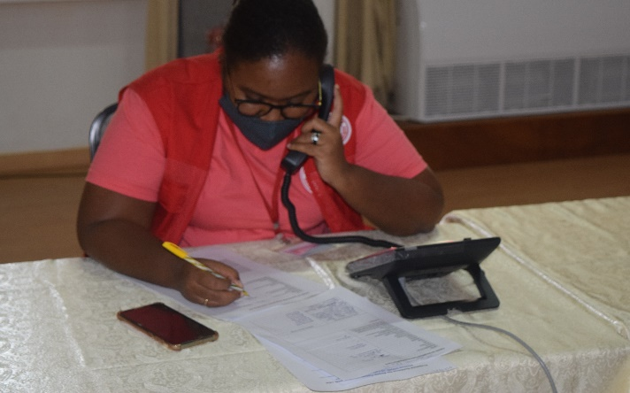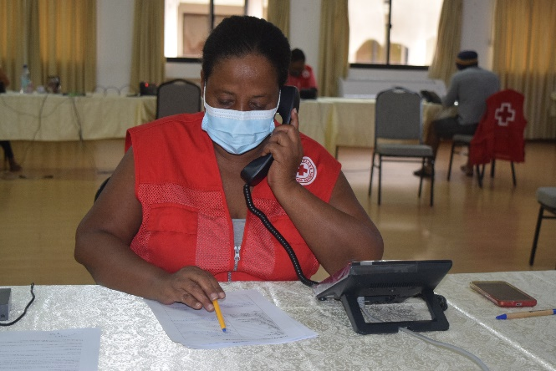
Volunteers during COVID 19; Contact Tracing
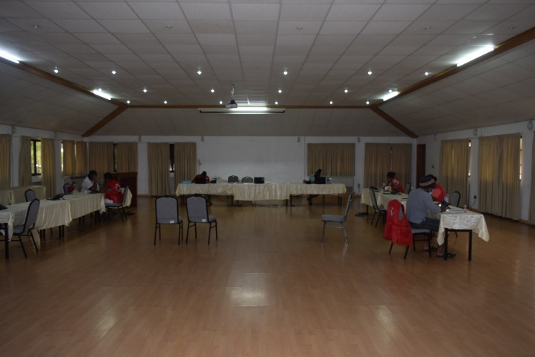
“Contributing Towards Community Resilience”

Annex 1: COVID 19 Communication Plan

COMMUNICATION PLAN

Whilst implementing activities during the COVID 19 pandemic, it was also of paramount importance for the NS to have an effective Communications Plan. And this was developed as soon as possible to guide all communications activities.

The importance of communication and education in any programme and activities is one of the most important tool/strategy in increasing knowledge, eliminate barriers and promote behavior change amongst others.

Whilst the ultimate goal of this Communication Plan is to ensure credible and consistency in communicating information, another main component of this plan is to use it as an advocacy tool for resource mobilization and secure additional funding. For the past years, the RCSS has more or less reduced the number of activities and programmes implemented due to a lack of funding and human resources; and with no designated staff responsible for communication, this has also created an impact on the image of the NS.

The COVID 19, although a crisis, and a first of its kind that we have to deal, also brings along certain advantages. It has proven that the RCSS is still being considered one of the most credible humanitarian organisations in the country and at the moment the RCSS is working in close collaboration with the Ministry of Health in Contact Tracing for the COVID 19. We are also providing trainings in Psychological trainings to RCSS volunteers and other local NGOs should there is a need to intervene. We are using this as leverage to advocate for funding and other resources for the NS. We hope that this situation will encourage the government to provide more assistance to the RCSS.

The goal of the NS vis-à-vis communication is to at least have something in the media on a weekly basis; and it has proven to be quite rewarding. We have received media coverage on a weekly basis from all media houses in the country, we aim to try to sustain this to promote the activities and image of the NS.
.
The maximum use of the electronic and print media has proven to be effective due to the high literacy rate in the country and access to television and radio. Informed, motivated and committed people can help us achieve the desired objectives especially during the COVID 19 crisis.

Target Groups
- General public
- Media Houses
- Ministries/Agencies
- Youth
- Elderly
- School Children

Our objectives
This Communication Plan is developed to assist in the implementation of activities of the COVID 19 pandemic in Seychelles as per the following objectives:
- To promote better understanding of the situation
- The roles and functions of the RCSS in this situation
- To mobilise everyone to take their responsibility
- To encourage adherence to set guidelines and principles of the current situation (COVID 19)
- To work alongside key partners in reducing transmission and encourage good practices and hygiene
- To promote the work of the National Society and that of the Federation and relevant partners
- To encourage other people to take care of the those most vulnerable
- To standardize internal and external communications in relation to COVID 19.
- To ensure that credible information is provided at all times.

Communication Channels
Presentations
Trainings
Radio and Television
One to one
Newspapers
Live interviews on Radio & television
Spots on Radio & television
Text messages
Phone calls
Adverts & featured articles in newspapers
Information products (such as posters, banners)
Social Media (Facebook, E‐Newsletter)

Expected outcomes
- Increased trust in the NS.
- Increased relationships with key partners.
- Behaviour change in the way people operates vis-a vis COVID 19
- Increased awareness of the NS.
- More support.

WORKING WITH THE MINISTRY OF HEALTH
The Ministry of Health, MoH, has always been an operational partner of the NS. However, our conjunctive, simultaneous efforts towards national health and safety both medically and psychologically were called to action in 2020 when Covid 19 struck Seychelles.

From the first report of a case in Seychelles in March 2020, the RCSS was represented on the Integrated Disease Surveillance and Response Committee of the Ministry of Health, as a member alongside other partners such as the Police, the Department of Tourism to name a few.

Operationally, the Ministry of Health called upon the NS to assist in Contact Tracing. Twenty plus (20+) volunteers were mobilized at the Ministry’s Headquarters, at Mont Fleuri on a daily basis for about 4 weeks.

They also assisted with data entry and provided Psychosocial Support to people affected by the situation.
And since Contact tracing was new to the NS, the need to introduce and empower our active volunteers on the subject was identified as a priority.
Subsequently, training sessions on COVID 19, and Contact Tracing were conducted by personnel from the Ministry of Health and volunteers of the RCSS.
Eight (8) sessions were conducted; two (2) at the MoH Headquarters at Mont Fleuri, Mahe, four (4) at the RCSS Headquarters on Mahe and two (2) on La Digue for Inner islands volunteers
Besides imparting knowledge to our volunteers about Contact Tracing, A further aim of the training sessions were to equip volunteers and staff with knowledge and skills to act promptly during the COVID 19 crisis and to assist the vulnerable.
The sessions were held in April 2020.
A half-day sensitization and training session was also held after the initial series in April. Same was done with the aim of preparing volunteers who would be on standby to boost up assistance and support to the MoH should the need arise.

The facilitation of the training was from the Ministry of Health, and among issues discussed were; surveillance of coronavirus, safety procedures in work and public places and personal hygiene.

PSYCHOSOCOLOGICAL FIRST AID
For the first quarter 2020, six (6) Psychological First Aid sessions were conducted with over 50 RCSS volunteers and staff , as well as members of Non-Governmental Organizations (NGOs) in the country.

The training and inclusion of other individuals besides RCSS volunteers and staff, were important as it was noted that the number of request for PFA was increasing from work places and infected/affected individuals.

The outcome was the increased knowledge of all participants, as well as the objectively improved team work amongst RCSS volunteers, staff and local NGO members.

Over the months of 2020, with the pandemic still very much apparent and not showing signs of ending, the MoH once again called upon the NS during the second quarter of the year. This time requiring our assistance to set up tents at health facilities around the islands for screening purposes.

A total of 12 tents were provided to the MoH. The RCSS provided advise for the location of the tent which were put up with the assistance of the Seychelles People’s Defence Forces (SPDF).

WORKING WITH THE MINISTRY OF EDUCATION (MoE)

The Ministry of Education remains one of our closest auxiliary partners over the years and since the arrival of Covid 19 in Seychelles, we have collaborated even closer in order to protect our children and mitigate the impact of the virus upon their health.

Kits for Kids

One of the first and most important outreach actions taken amongst others within the community was the procurement and distribution of Hygiene kits comprising of hand sanitizers, soap, hand wash liquid, tissues and wipes to children in different schools around Mahe, Praslin and La Digue. Also included was a simple information leaflet about Covid 19 symptoms and preventive actions.

The objective of this project was to ‘empower the children with the know-how and the equipment needed to protect themselves and others around them from the virus’. The expected outcome was for the recipients to:

- Know the importance of good personal hygiene and care
- Know the parts of the body where germs collect
- Be aware of personal hygiene practices that are easy to apply
- Be educated about the most effective personal hygiene practices to apply
- Be equipped with the necessary items for their basic protection against the virus
This activity took place just after the first cases of Covid 19 were reported in Seychelles in March 2020.

We originally bought the above-mentioned items in bulks and with the help of our volunteers and staff, put together thirteen hundred (1300) kits which we initially distributed to children in schools in different regions. We mostly targeted children under the Dedicated Fund Program but we also covered other children identified with the need for such kit by respective school managements.

Support with RCCE

- During the first week of school after the lockdown. In June 2020, the NS assisted the Ministry of Education to sensitize children about the Best Practices of staying safe in the classroom and during break times.
This activity included the mobilization of some 25 volunteers and staff of the RCSS mostly concentrating around creche and primary schools in the North and Central regions of Mahe.

The aim of the activity was to assist the MOE in the screening procedures required to ensure that precautions are taken as early as possible, in order to alleviate and control the additional expected impact of reopening schools in the country after its closure during the lockdown and to assess the preparedness and response level of the schools.

Additionally, it would assist to mitigate the level and effect of any possible further spread of the COVID 19 virus.

The actions taken and observations made were used to disseminate information through reporting and recommendations based on the evaluation, to the MoE, the IFRC, PIROI and the NS for consideration and further actions as necessary.

At the end of the activity it was observed as follows
:
- The RCSS contributed to the efforts of prevention of further spread of the COVID 19 virus within the community beginning from the schools.
- Parents were reassured that measures were being taken by multiple partners concerned to ensure that the health and safety of their children were being ensured as best as possible
- Children’s knowledge of the symptoms of COVID 19 and the Best Practices based on safety guidelines were enhanced
- The confidence of volunteers and staff members of the RCSS were empowered further through practice of screening and psychosocial counselling
- The visibility of the RCSS and its outreach in the community were enhanced

All through 2020, the NS continued to support the Ministry of Education and vulnerable families, especially those with children through our RCCE and humanitarian actions.

LANDFILL FIRE FROM 19TH -24TH SEPTEMBER 2020

Report of a fire on the Providence landfill was received on the 19th September 2020 and first response agencies were notified for activation.

The Seychelles Fire and Rescue Services Agency was the first on site followed by the Department of Risk and Disaster Management (DRDM), The RCSS arrived shortly after once we had been informed and already activated our Emergency Response standby Team.

The first RCSS representatives to arrive on the landfill site were staff members followed progressively by volunteers. Once we had set up our respective command post, there were a dozen staff and volunteers on the scene.

The RCSS was given the responsibility of coordinating the on-site Command Post set up to take up matters on the physical site and feedback to the National (NOC) comprising of Government and stakeholder agencies and departments.

The roles of the on-site Command Post team were outlined as follows:

- To ensure accountability of logistical and psychosocial support coming in and distributed from the post to on ground personnel including those on the landfill.
- To ensure control and records of all vehicles and persons coming to the Command Post and to anywhere around the site including the landfill area.
- To ensure timely and accurate data update and compiling
- To assist the Ministry of Health, which also had members deployed; in any eventuality where First Aid might be necessary.
- To ensure that officers on the landfill site including fire fighters both from the SFRSA and the SCAA Fire and Rescue, the police, the military and other personnel from other agencies (STAR Seychelles, Vijay, etc…) are kept hydrated and psychologically supported.
- And very important in all cases to ensure that all COVID 19 related health and safety regulations were actively observed.

RCSS was present on the landfill fire site from the 19th September on 24-hour basis. Staff and members were rotated to accommodate the workplan.

NS volunteers on standby also conducted visits in residential areas immediately around the fire site to evaluate potential hazards from the emanating smoke and fumes from the burning landfill and also advise partners (school administrations and district authorities in the vicinity) on actions to take to reduce risks of damages to their students and constituents respectively.

During the interval, we had visits from former President Danny Faure, former Designated Minister Ms. Macsuzy Mondon, former Minister for Environment Mr. Wallace Cosgrow and the Principal Secretary for Environment Mr. Allen Decommarmond.

The first briefing with representatives of all partners on the site was conducted on the 20th September 2020 at 1300hrs and present were: Department of Risk and Disaster Management, the Red Cross Society of Seychelles, the Seychelles Fire and Rescue Services Agency, Land Waste Management Agency, Ministry of Health, the police and private agencies including STAR Seychelles and UCPS.

Each respective agency gave a brief recount of their mandates, reason for being part of the response team for the particular event and update of respective roles so far.

The same briefing were repeated every morning until step-down once the fire had been completely put out.
The RCSS received donations on behalf of the response team from Seychelles Breweries, Gopi Supermarket branch and private individuals

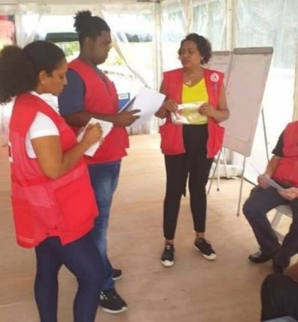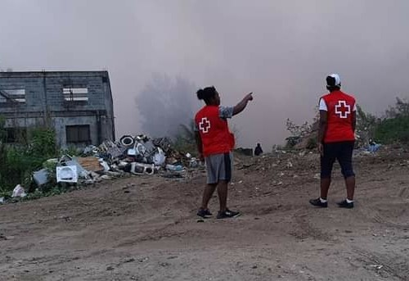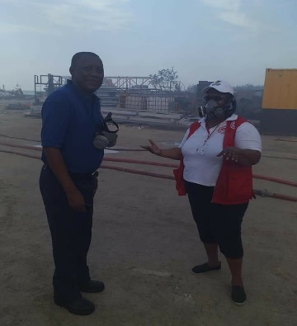

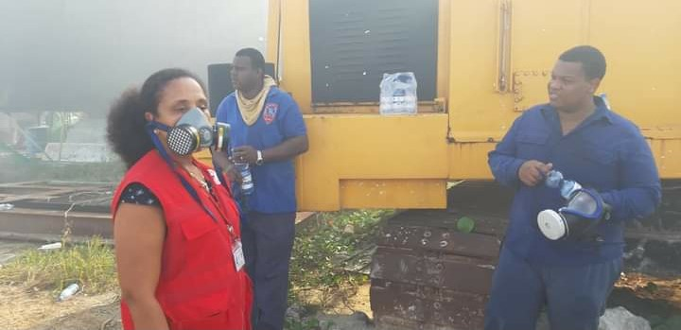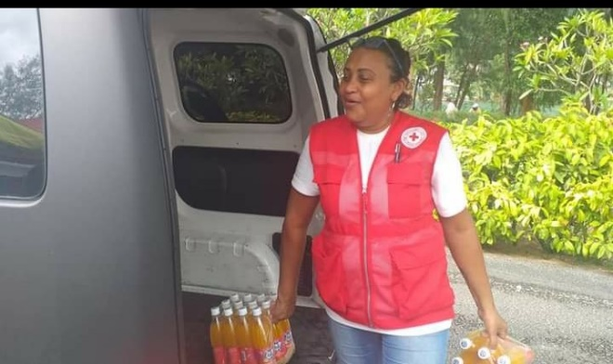

RAISING THE STANDARDS OF THE RCSS HEADQUARTERS

With the administrative changes within the RCSS Leadership and Management and most importantly, with new challenges brought on by COVID 19, it was deemed necessary upgrade the standards of the Headquarters so as to ensure and maintain the comfort and safety of our staff and volunteers who would be frequently coming to our offices.

The NS procured and made available items including hygiene kits, masks and extra sanitizer for use by staff members and volunteers on sites including those doing Contact Tracing sessions.
Governance office – It was also a matter of importance to provide for an office at HQ for National Committee Members. The Governance Office would allow NCMs to access and respond to their emails as well as to review documents in a conducive, private and above all safe space.

The NS therefore decided to undertake some general maintenance work on; and basic furnishing of the Governance Office so as to render it conducive and safe for use by NCMs and related officials.

UPGRADING OF RCSS IT SYSTEM

With the load of work, we have where we often have to involve volunteers, we identified the need to enhance our IT communication and navigating network so that we can facilitate and upgrade our updating and reporting system for faster and broader usage.

For the facilitation of this operation, the NS also purchased a new server which would be faster, giving staff and volunteers faster browsing freedom for better communication, research and networking.

VOLUNTEER DATABASE

The Red Cross Society of Seychelles boasts over a hundred (100) volunteers with more than three quarters (¾)of the number activated whenever the need arises for standby or direct involvement in events and activities on national and community levels; as well as regional if that should be necessary.

Considering the richness and diversity of the various skills and experiences of our pool of volunteers whether they already had them upon joining us or acquired them over the years through our own Empowerment programme.

The RCSS included as part of our Strategic Plan for 2020-21; the creation of an active Database system which would include the particulars of all our volunteers including their skills and areas of expertise as well as their preferred area of voluntarism, so as to facilitate channelling of volunteers for respective activities.

Skills areas vary from Youth leadership, First Aid, Community Engagement, Humanitarian Aid as well as supportive roles alongside the NS such as driving, office work, activity coordination, etc…

The database which is currently being used as per its original intention, is dynamic and active so that it can be updated on a regular and continuous basis as we get more volunteers joining us especially now that we have established our visibility and presence alongside communities.

RCSS PARTICIPATION IN THE NATIONAL GENERAL ELECTIONS

General elections were held in Seychelles on 22–24 October 2020 to elect the President and members of the National Assembly.
The National Assembly elections had been due in 2021, but in July 2020 were brought forward by President Danny Faure in order to hold them together with the presidential elections, a proposal supported by Linyon Demokratik Seselwa (LDS) and other opposition parties.
The presidential elections were won by Wavel Ramkalawan of the Linyon Demokratik Seselwa (LDS), with the LDS also increasing its majority in the National Assembly, winning 25 of the 35 seat.

Some 100 volunteers of the NS were trained in Election procedures and the roles of the RCSS at polling stations; especially in the context of COVID 19 where our presence on sites would extend from providing basic logistics, e.g., water and First Aid assistance to ensuring that social distancing and wearing of face masks is observed.
The training sessions were held by facilitators from the NS and the National Election Commission (NEC)
Volunteers were deployed from the 23rd October where voting was being held on the outer islands and other special stations and on the main polling day of the 24th October. They were posted at all polling stations on the three main islands.
The RCSS Command Centre at the main Headquarters was activated from the 23rd October at 0600 to the morning of the 25th October.
The participation of the RCSS during the elections turned out well and successful and the NEC expressed their thanks to the NSfor our presence and assistance in the process.

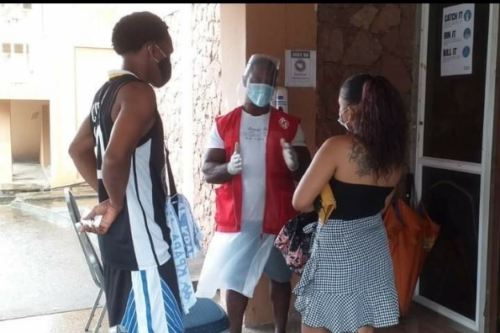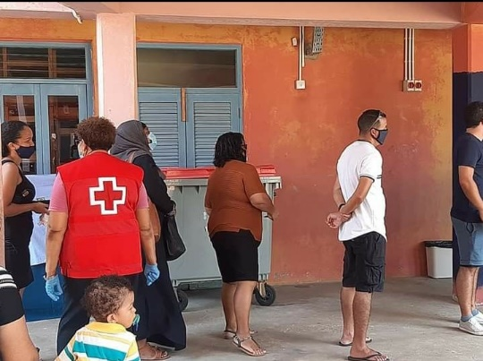

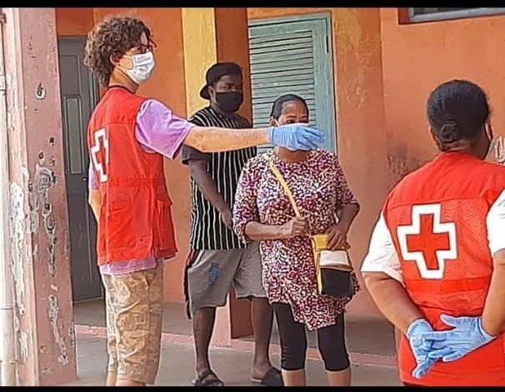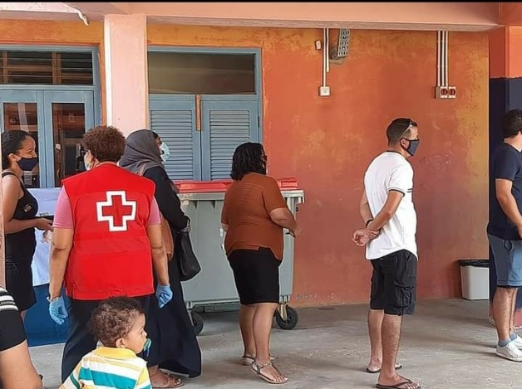

RCSS FINANCIAL STATEMENT 2020
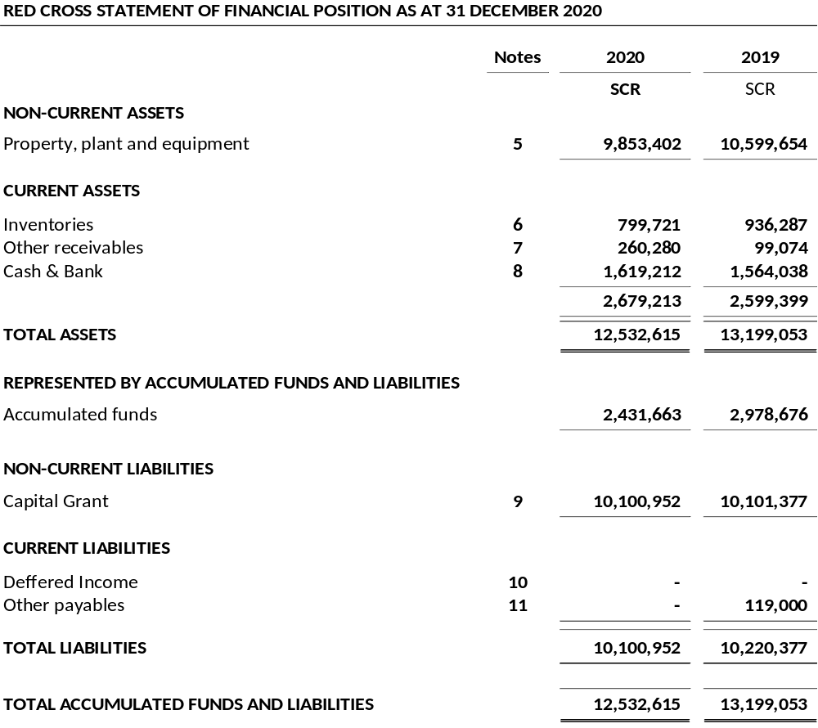

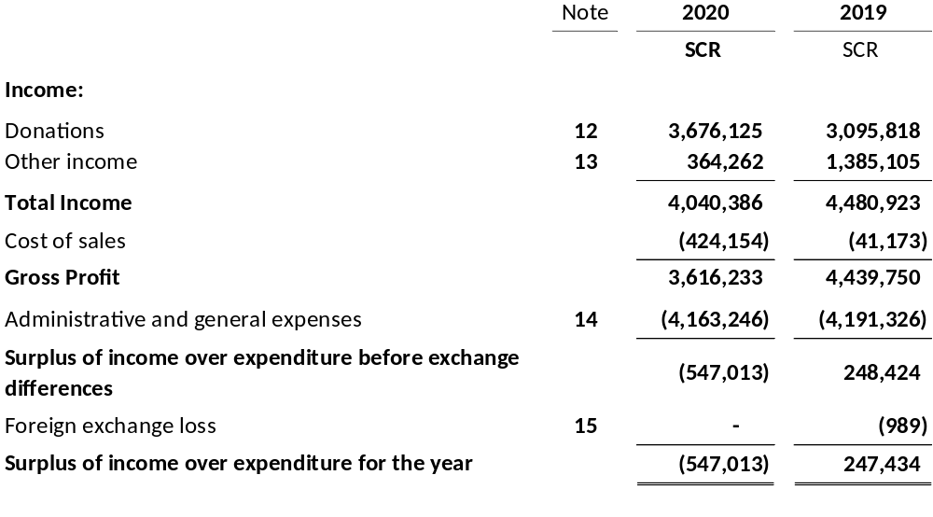

 |  |  | Accumulated Surplus |  | Total
 |  |  | SCR |  | SCR
Balance at 1 January 2019 |  |  | 2,648,896 |  | 2,648,896
Surplus for the year |  |  | 329,780 |  | 329,780
Balance at 31 December 2019 |  |  | 2,978,676 |  | 2,978,676
Balance at 1 January 2020 |  |  | 2,978,676 |  | 2,978,676
Surplus for the year |  |  | (547,013) |  | (547,013)
Balance at 31 December 2020 |  |  | 2,431,663 |  | 2,431,663

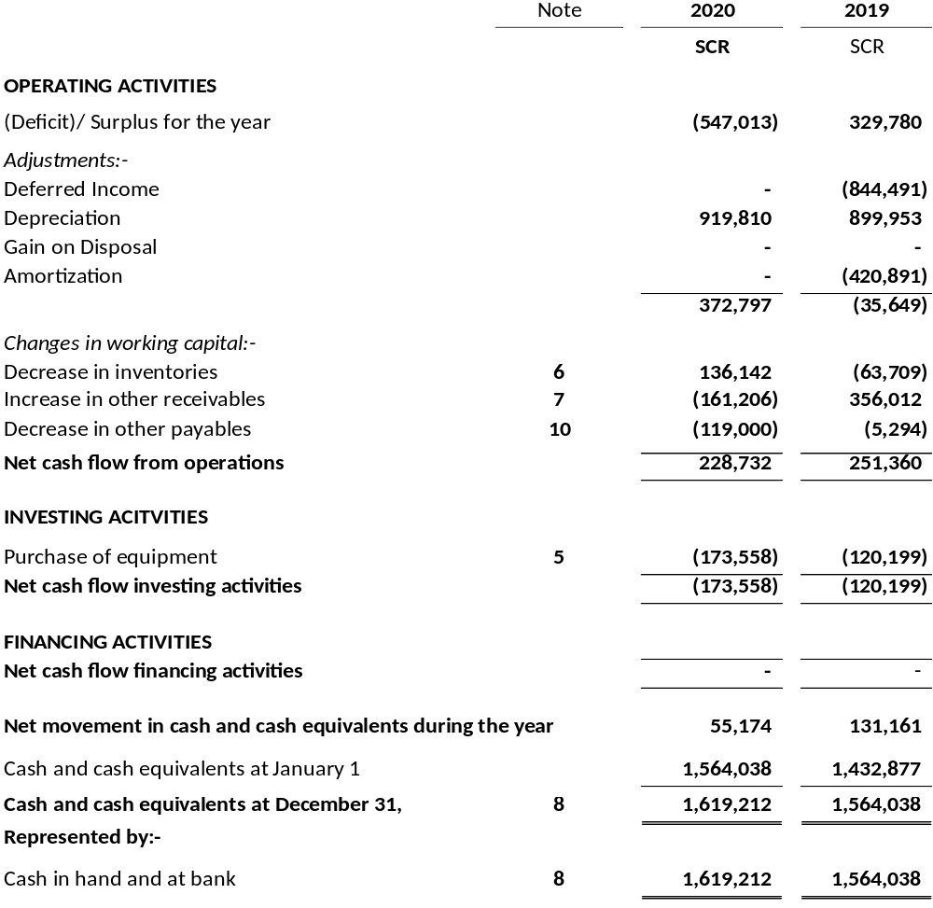

CONCLUSION

The first year was a challenge for the NS; first time dealing with a crisis at that level and at the same time with a minimum of resources. The NS was actually operating with only (4) full time staff; one Programme Coordinator, one Administration Officer, a Logistics Officer and a new Secretary General. The Finance Coordinator was coming on a parttime basis.

In a way, the communication flow was easier as there were not many of us, but on the other hand it also involved more work in disseminating the much-needed information to the population, volunteers and partners.

The first year was mostly about setting the scene, reviewing the different resources, policies etc…and profiling the NS for what is described as the harder task ahead. The importance of consistence, credible and regular Information/communication was vital to build trust, advocate for those in need and for the NS, as well as the promotion of good hygiene/safety during the COVID 19.

But through it all, we managed to increase the visibility of the NS, implemented activities pertaining to response and preparation in COVID 19 and increased collaboration with partners.

Although we had to contextualize some of our activities for 2020 in adaptation of the COVID 19 ‘new normal’; it has not been difficult to adapt.

We had already aligned our implementation plan for Capacity Building to the RCSS Strategic Plan 2017-2021: Contributing towards Community Resilience. A theme in itself reflecting adaptability and flexibility and the RCSS’ commitment to preparedness and empowerment.

The COVID 19 Contingency Plan was a welcomed strategic document easing our interactions and short- and medium-term actions to be present, efficient and effectively active alongside people in communities at this time.

Our advocacy strategy proved its worth in making the RCSS more visible to the public who have come to look upon and depend on us, as a vital means of support during the pandemic.

As always, our volunteers were on the frontline from day one, giving their best to a situation they have never dealt with before, ensuring that they are well versed in the situation so as to be able to impart this knowledge to the targeted population. It is mainly through these communications, advocacy that the RCSS is today enjoy being the leading and trust worthy, humanitarian organization in the country.

